Island Homes
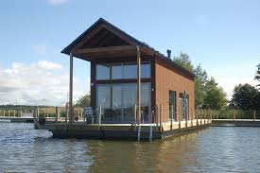
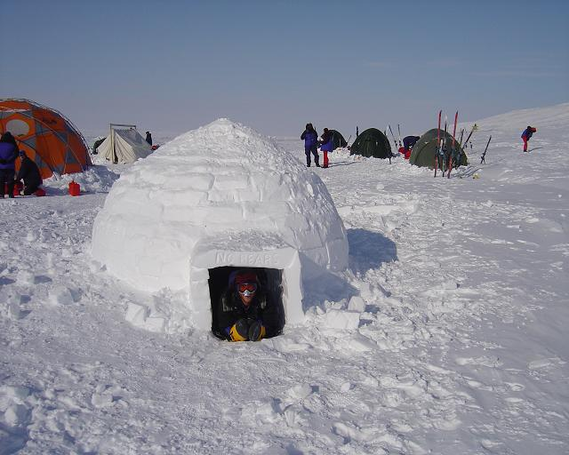
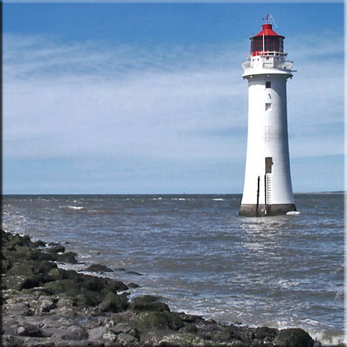
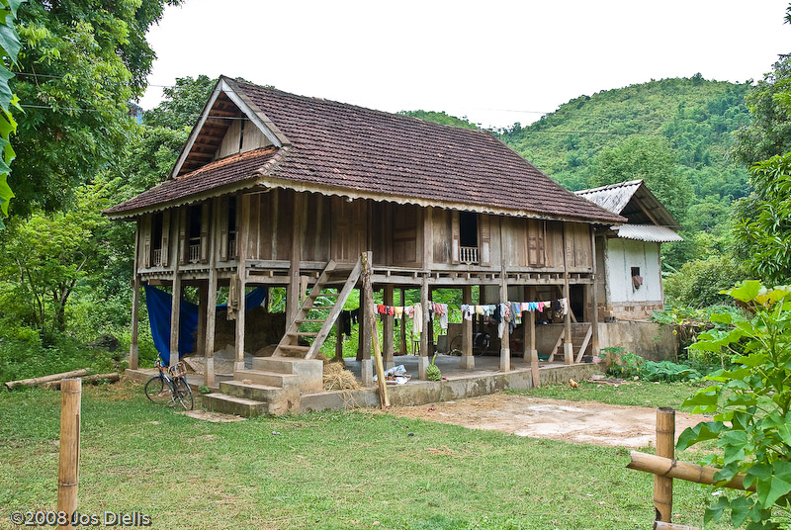
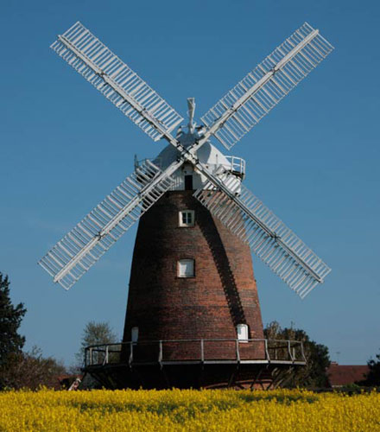
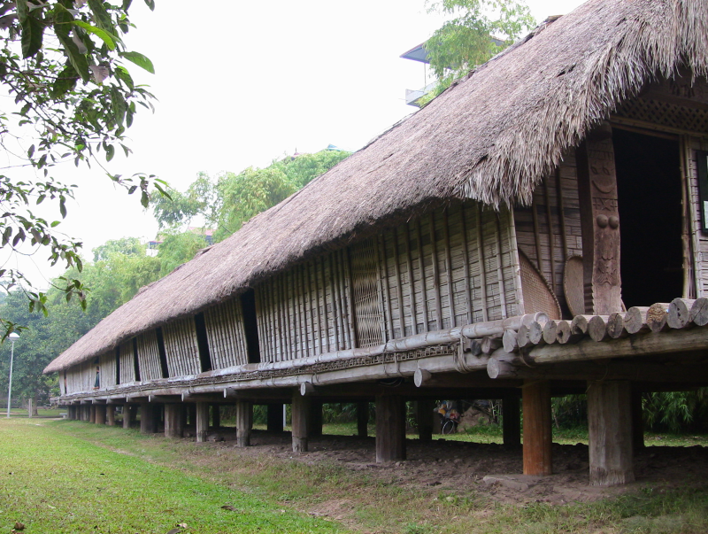
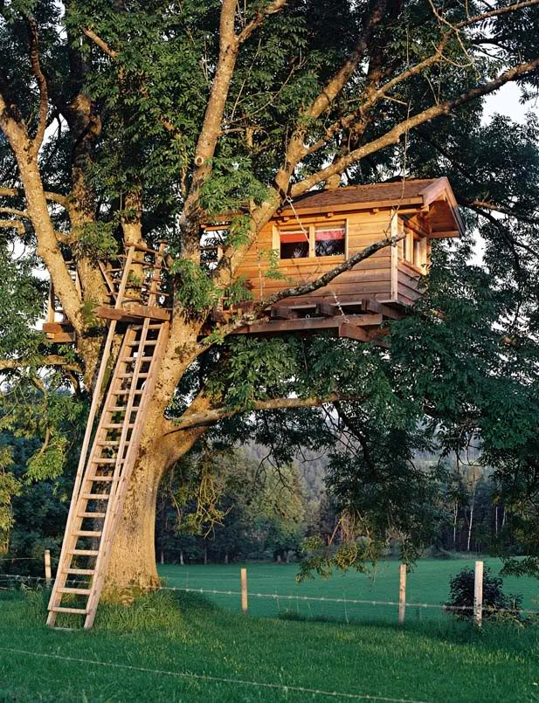




Reader (Vocabulary)

earliest humans الانسان البدائى | forest غابة | safe امن
face يواجه | danger خطر | paintings رسومات
different مختلف | wood خشب | bricks قوالب طوب
mud طين | kinds انواع | lighthouse منارة
bay خليج | top قمة | paint لون
safely بأمان | electric كهربى | Greece اليونان
windmill طواحين الهواء | olive trees اشجار الزيتون | oil زيت
pacific islands جزر المحيط الهادى | stilts قضبان خشبية | ground الارض
nests عشش | wood خشب | covered in مغطى ب
leaves اوراق الشجر | roof سقف | ladder سلم
floating عائمة | adobe houses البيوت اللبنية | material مادة خام
bamboo شجر البامبو | light يضىء | floating market سوق عائم
spend يقضى | lucky محظوظ | caravan بيت متحرك
blocks كتل | igloo بيت جليد | Inuit الاسكيمو(قبائل الجليد)
build يبنى | around حول | looking for يبحث عن
trips رحلات | across عبر | warm دافىء
animal skin جلد حيوان | unusual غير عادى | cheap رخيص
cliffs منحدرات | mixture خليط | mud طين
straw قش | dry جاف | popular محبوب
electricity الكهرباء | farming الزراعة | apartments شقق
skyscrapers ناطحات سحاب | space مسافة | roll يلف
protect يحمى | Japanese اليابانيون | polite مؤدب
take off يخلع | Asia أسيا | village قرية
collect يجمع


Part (1)
Pages: 2:5
The Earliest Human

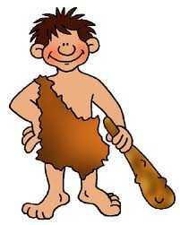
1- Where did the earliest humans live?
They lived in forests.
2- Why did the earliest human sleep in trees?
To keep them safe from danger.
3- What was the danger that the earliest humans faced?
The weather and the wild animals.
4- When did the earliest humans start to live in caves?
About 150,000 years ago.
5- What do the paintings in the caves show?
They show that earliest humans used caves as homes.
6- Where do people live today?
They live in different kinds of homes.
7- What are homes made of?
They are made of wood, bricks, mud and trees.

The Lighthouse
8- What do lighthouses do?
They help ships in the sea get home safely.
9- How do the lighthouses help the ships?
They give lights that show the ships where they are.
10- How are lighthouses different now?
They are now electric.
The Windmill
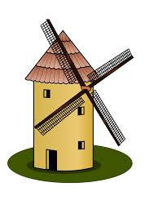
11- Why are most of houses in Greece white?
To keep the house cool inside.
12- Where does Alexia live?
In the windmill.
13- What was the windmill used for in the past?
For making bread.
14- What does Alexia’s family grow in their garden?
Olive trees.
15- Why Alexia’s family grow olive trees in their garden?
To make oil.
Part (2)
The Stilt house

1- Why do people on the pacific islands build houses on stilts?
To keep the house dry and safe from the heavy rain.
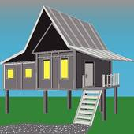
2- How high are the stilt houses?
Three or four metres off the ground.
3- Why does it take a long time to build a stilt house?
To find the right wood for the stilts.
4- Why are the stilt houses good for the hot weather?
Because they are cool inside.
5- How do people get in and out the stilt house?
By ladders.
6- Why do animals live under the stilt house?
Because it’s not sunny or hot there.
The Longhouse
7- Where are the longhouses?
They are in the Southeast of Asia.
8- How are longhouses different from stilt houses?
They are bigger and it can be home for all the families of the village.
9- Where are longhouses built?
In South Asia.
10- How long can a long house be?
About 300 meters.
11- Why do Suhail think that long houses are good for children?
Because they all live like a big family there.
12- Who does Suhail live with in the longhouse?
His parents, brothers, sisters, grandparents, aunts and uncles.
The Tree House
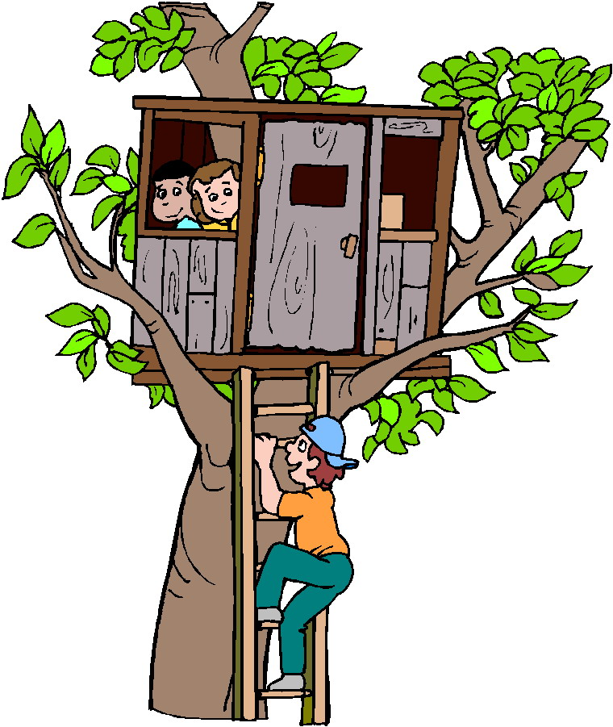
12- How do tree houses look from far away?
Birds’ nests.
13- How high are some of the tree houses?
About 50 meters.
14- What are tree houses made of?
They are made of Wood and their roofs are covered
in leaves.
15- What is a tribe?
A group of people.
16- Why did people build tree houses?
To stay safe from the other tribes and from dangerous animals.
17- How do people climb up and down the tree houses?
By ladders.
Part (3)
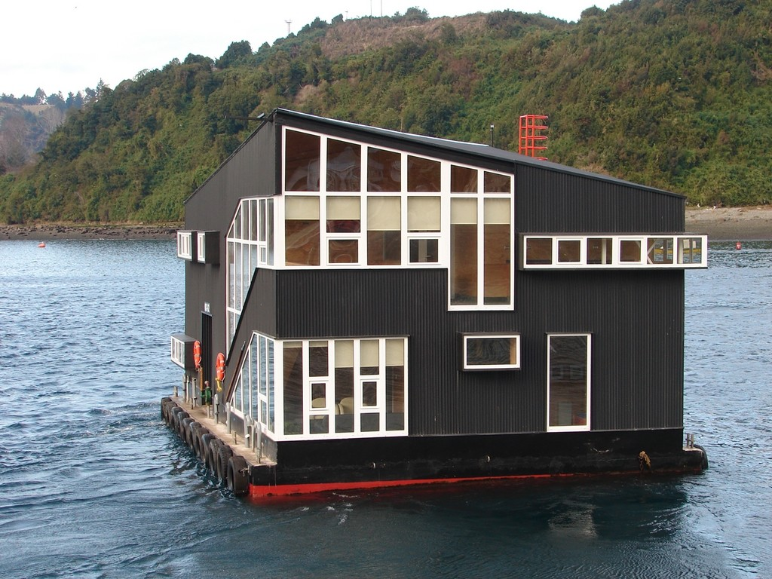
Floating House
1- Where are the floating houses?
In Thailand and Cambodia.
2- What are the floating houses made of?
Bamboo
3- What is bamboo?
It’s a light material that floats very well on water.
4- Why are floating houses made of bamboo?
Because it is a light material that floats very well on water.
5- Where do people in Thailand and Cambodia go shopping?
In floating markets.
6- How do children spend their time in Cambodia and Thailand?
The children swim and go fishing
7- What can lucky children do in Thailand and Cambodia?
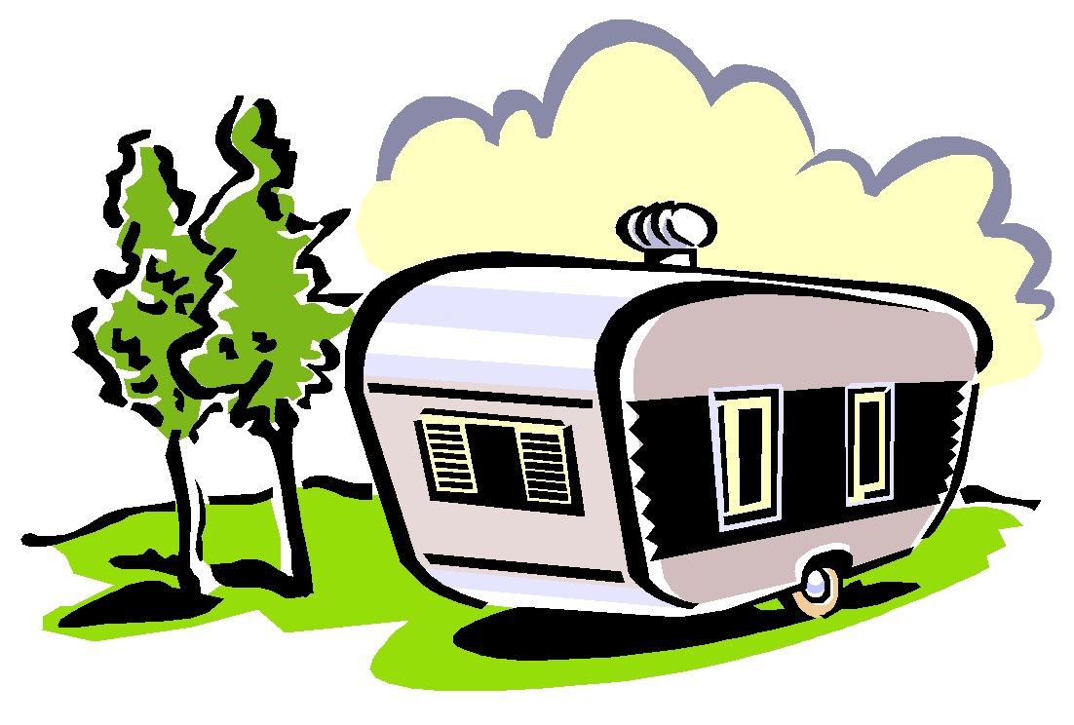
They can catch fish from their bedroom windows.
The Caravan

8- Where does Brianna live?
In a caravan.
9- How does Brianna help in the housework?
She finds wood for the fire.
10- What do people in Romany caravan like?
They like travelling.
The igloo
11- What is an igloo?
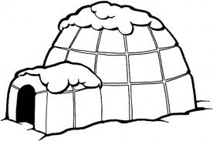
It is a kind of house that is made of blocks of snow.
12- Who builds igloos?
The Inuit people.
13- What are igloos made of?
Blocks of snow.
14- Why did the Inuit people live in igloos many years ago?
Because they travelled around looking for food.
15- When do the Inuit people live in igloos?
When they go on trips across the ice and snow.
16- Why are igloos small?
To keep them warm inside.
17- Why can’t people make fires inside?
bec. If we make a fire inside the igloo, the snow turns into water.
18- How do people stay warm inside?
By oil lamps or by clothes made of animal skin.

Part (4)
Cave houses

1- Wha is the difference between caves in the past and cave houses now?
In the past caves were simple but now cave houses have got rooms.
2- What is the first thing built in cave houses?
The living room.
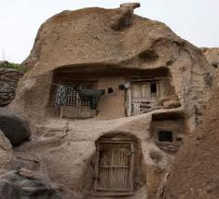

3- Why does Pablo like his cave house?
Because everyone wants to see Pablo’s
unusual house.
4- Why is it cheap to live in a house cave?
Because you can make rooms from cliffs.

Adobe houses

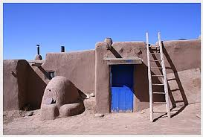
5- What is adobe?
It is a mixture of mud and straw.
6- Where can we find adobe houses?
In hot and dry countries.
7- How do people make adobe houses?
People make bricks from a mixture of mud and straw and leave them dry in the hot sun.
8- Why are adobe houses (mud houses) very popular?
Because they are cheap and easy to build.
9- Why do the young people in the island of Taquile leave it?
To find work in cities.
10- How is the life on the island of Taquile?
There is no electricity and people live off farming and making clothes.

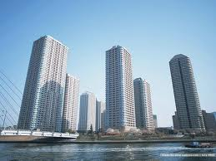
Houses in Japan

11- Where do the Japanese people live?
In small apartments in skyscrapers.
12- Why do the Japanese people take off their shoes before they enter a house?
Because it’s polite.
13- What do the Japanese people use the floor for?
Sitting down and eating a meal or lying.
14- Why do the Japanese people have space in their houses during the day?
Because they roll their beds up in the morning.
15- What materials do people use for building?
Wood, brick, bamboo, ice, mixture of mud and straw and trees.
16- What can houses protect us from?
The bad weather.
It has been finished by the grace of Allah.

General Exercises
Island homes
1- Where did the earliest humans live?
…………………………………………………………………………………………………
2-Why did the earliest human sleep in trees?
.......................................................................................................................................
3- What was the danger that the earliest humans faced?
…………………………………………………………………………………………………
4- When did the earliest humans start to live in caves?
…………………………………………………………………………………………………
5- What do the paintings in the caves show?
………………………………………………………………………………………………….
6- Where do people live today?
.........................................................................................................................................
7- What are homes usually made of?
…………………………………………………………………………………………………..
8- What do lighthouses do?
…………………………………………………………………………………………………..
9- How do the lighthouses help the ships?
……………………………………………………………………………………………………
10- How are lighthouses different now?
...........................................................................................................................................
Complete:
1- The earliest human slept in trees to………………………….
2- Most of houses in Greece are in ………………….
3- Alexia lives in……………
4- The windmill was used for……………………. in the past?
5- Lighthouses help ships in the sea get home ……………..
6- The earliest humans used caves as …………………
7- The earliest humans lived in ………………………..
8- The earliest humans start to live in caves about ……………… years ago.
9- Homes are usually made of……………………..
10- The lighthouses help the………………..

1- Why do people on the pacific islands build houses on stilts?
................................................................................................................................
2- How high are the stilt houses?
……………………………………………………………………………………………
3- Why does it take a long time to build a stilt house?
……………………………………………………………………………………………..
4- Why are the stilt houses good for the hot weather?
…………………………………………………………………………………………….
5- How do people get in and out the stilt house?
…………………………………………………………………………………………….
6- Why do animals live under the stilt house?
……………………………………………………………………………………………
7- Where are longhouses built?
…………………………………………………………………………………………….
8- How long can a long house be?
……………………………………………………………………………………………
9- How do tree houses look from far away?
…………………………………………………………………………………………….
10- How high are some of the tree houses?
…………………………………………………………………………………………….
11- What are tree houses made of?
……………………………………………………………………………………………
Complete:
1- Some of the tree houses are about…………meters high.
2- Tree houses are made of……………………
3- Tree houses roofs are covered in……………..
4- A tribe is……………………….
5- People built tree houses to………………………..
6- People climb up and down the tree houses by……………………..
7- It takes a long time to build a stilt house to find ……………………
8- Suhail live with……………………….in the longhouse.
9- Tree houses look from far away like…………………..
10- Animals live under the stilt house because it’s ………………………..

1- Where are the floating houses?
……………………………………………………………………………………………..
2- What are the floating houses made of?
…………………………………………………………………………………………….
3- What is bamboo?
…………………………………………………………………………………………….
4- Why are floating houses made of bamboo?
…………………………………………………………………………………………….
5- Where do people in Thailand and Cambodia go shopping?
…………………………………………………………………………………………….
6- How do children spend their time in Cambodia and Thailand?
…………………………………………………………………………………………….
7- What can lucky children do in Thailand and Cambodia?
……………………………………………………………………………………………..
8- What is an igloo?
……………………………………………………………………………………………..
9- Who built igloos?
……………………………………………………………………………………………
10- What are igloos made of?
…………………………………………………………………………………………….
11- Why are igloos small?
……………………………………………………………………………………………..
Complete:
1- The Inuit people live in igloos when…………………………
2- The floating houses made of……………….
3- Brianna lives…………..
4- Brianna finds wood ………………….
5- Igloos are made of……………….
6- The floating houses are……………………
7- ………………… built igloos.
8- Igloos are small to…………………..
9- …………………….are in Thailand and Cambodia.
10- Bamboo is……………………

1- What is the first thing built in cave houses?
…………………………………………………………………………………………….
2-Why do Japanese people take off their shoes before they enter a house?
…………………………………………………………………………………………….
3- Why does Pablo like his cave house?
…………………………………………………………………………………………….
4- Why is it cheap to live in a house cave?
……………………………………………………………………………………………..
5- What is adobe?
……………………………………………………………………………………………….
6- Where can we find adobe houses?
………………………………………………………………………………………………..
7- How do people make adobe houses?
………………………………………………………………………………………………..
8- Why are adobe houses (mud houses) very popular?
………………………………………………………………………………………………...
9- Why do the young people in the island of Taquile leave it?
………………………………………………………………………………………………….
10- How is the life on the island of Taquile?
………………………………………………………………………………………………..
11- What do the Japanese people use the floor for?
…………………………………………………………………………………………………
Complete:
1- We find adobe houses in……………………
2- The adobe house is……………….
3-……………………. is the first thing built in cave houses
4- Houses can protect us from…………………..
5- The Japanese people use the floor for……………………..
6- People put the bricks from a mixture of mud and straw in the………….
7- …………………are made of straw and mud.

